BPM/BRM Deployment Master

**BPM/BRM Deployments Overview –**

Complex business logic can be modeled as a combination of business processes with business rules and complex event processing. BPM can be combined with the drools project to support one unified environment that integrates these paradigms where you model your business logic as a combination of processes, rules and events. Web-based tools like KIE Workbench allow you to model, simulate and deploy your processes and other related artifacts (like data models, forms, rules, etc.). All assets are stored and managed by the Guvnor Repository (exposed through Git) and can be managed (versioning), built and deployed.

Each BPM/BRM deployed project will be a maven artifact with its own group Id, artifact Id, and version. To integrate with BPM/BRM, MainetService must have to choose a target deployment version to be used at runtime.

**BPM BRM Deployments Master –**

BPM BRM deployment master will allow us to set target version of bpm projects that to be used by Mainetbpmservice at runtime. BPM BRM deployment master gives flexibility to add and update runtime bpm project deployment. In case of failure with newly added deployment we can simply rollback to older version without any down time.

Existing deployment list

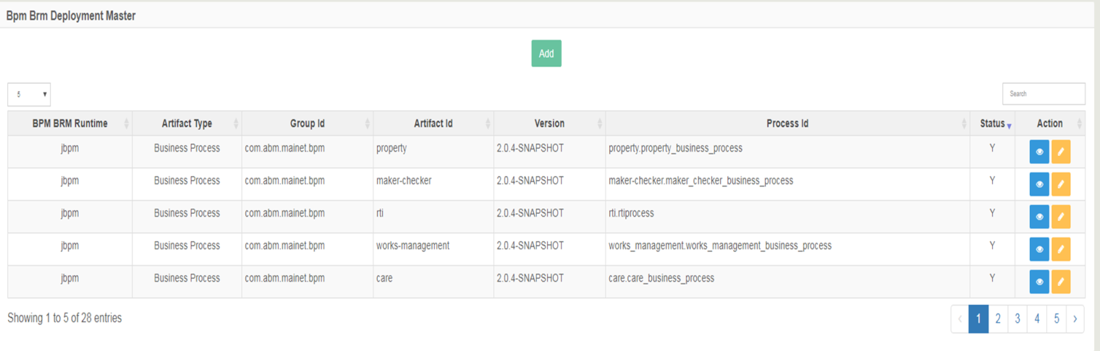

**Add new deployment –**

* BPM BRM Runtime: Runtime integrated technology (jBPM, Activiti bpm etc.)
* Artifact Type: Business Process or Business Rule
* Group Id, Artifact Id and Version: Mavens jar identification.
* Status: Active or Inactive (Yes/No)
* Process Id: Main/Parent BPM process Id. (Keep blank for rule project)
* Rule Flow Group: Rule Flow Group to execute (Keep blank for process project)

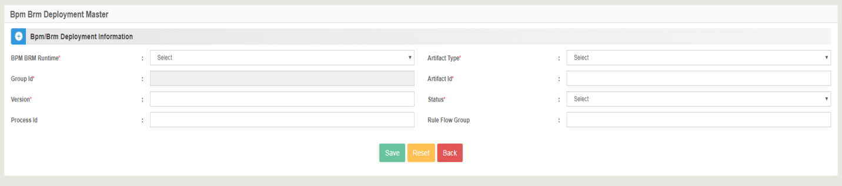

Example –

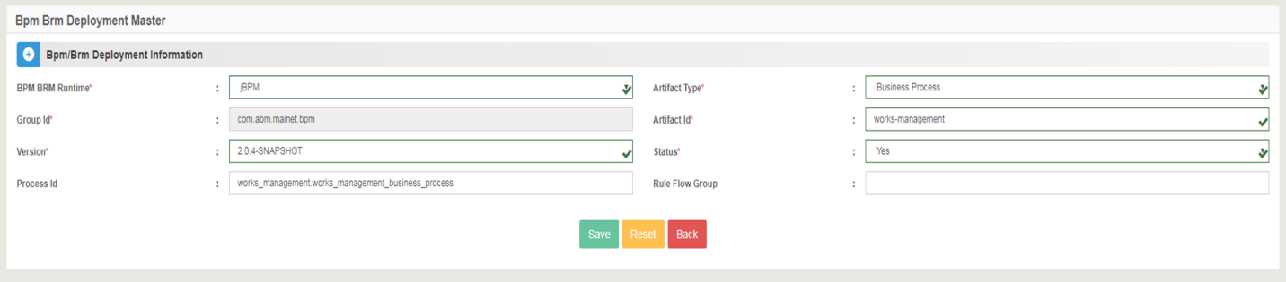

All entries should match actual data exist and deployed in BPM (Kie-wb) –

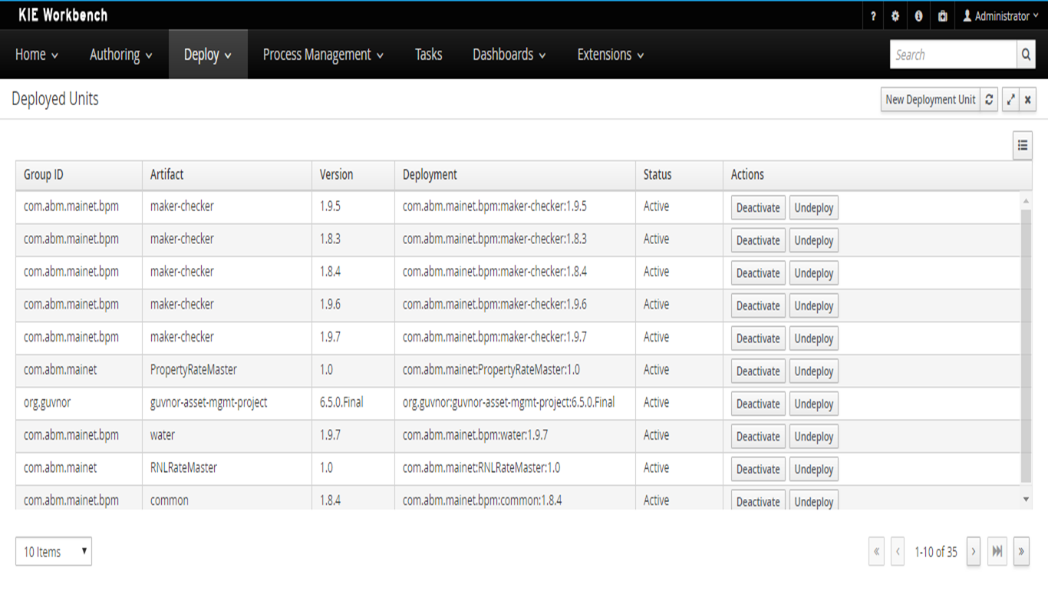

*Note – BPM BRM Process Deployment Master should contain at most one deployment active for each project.*

**Edit existing deployments –**

* Only status and version can be changed.
* Version is freely editable to put appropriate version of deployment unit.
* Updated version will be effective from new application related to this deployment.

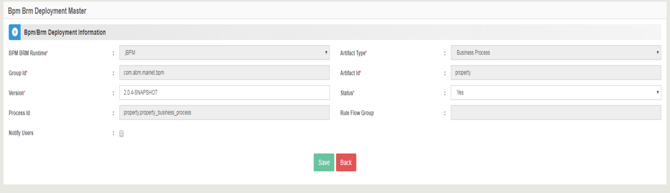

* When we update deployment units it may affects actual business flow depending on logic implemented in target versions.
* Whenever deployments get updated, it is good and required to send notification to all department users related to such changes.
* There is an optional check to notify department users. (Notify Users)
* If Notify Users is checked then list of department names will be displayed and we need to select particular department from the list.
* After submitting form all department users will be notified with new changes related to deployment.

